**Setting up the geonetwork over the windows operating system:**

1. WSL

To run geonetwork in windows we can either run directly using Java and Maven, or we have to use WSL.

Terminal:

PS C:\Users\opoda> wsl –version

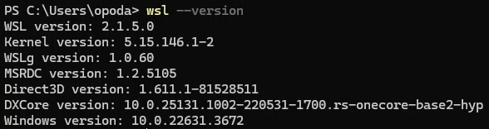

A wsl version is found in the system hence no need to install a new wsl version.

1. Installing Ubuntu

To install Ubuntu in the wsl we have to open a separate shell tab

PS C:\Users\opoda> wsl – install

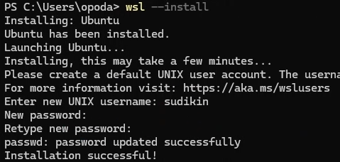

Ubuntu is successfully installed and a user and password has to be given.

1. Downloading geo-network
   1. The following directories are created documents/geonetwork_testing/

sudikin@DESKTOP-P01H8DT: ~$ mkdir documents

sudikin@DESKTOP-P01H8DT: ~$ cd documents/

sudikin@DESKTOP-P01H8DT: ~/documents$ mkdir geonetwork_testing

sudikin@DESKTOP-P01H8DT: ~/documents$ cd geonetwork_testing/

* 1. Downloading geo-network from github

We have shallow cloned that is installed only the last three commits(--depth 3 command) and downloaded all the submodules by carefully checking it(--recursive command).This ensures it requires less download time and minimum memory space.

Webpage: https://github.com/geonetwork/core-geonetwork/tree/main/software_development

sudikin@DESKTOP-P01H8DT: ~/documents/geonetwork_testing$ git clone –depth 3 –recursive https://github.com/geonetwork/core-geonetwork.git

1. Installing geo-network
   1. Change to folder within the geonetwork testing

sudikin@DESKTOP-P01H8DT: ~/documents/geonetwork_testing$ cd core-geonetwork/

* 1. Checking all the files and folders created within

sudikin@DESKTOP-P01H8DT: ~/documents/geonetwork_testing/core-geonetwork$ ls

On checking we see that all the files and folders have been created.Now we are prepared to install the downloaded geonetwork file from in step 3 above

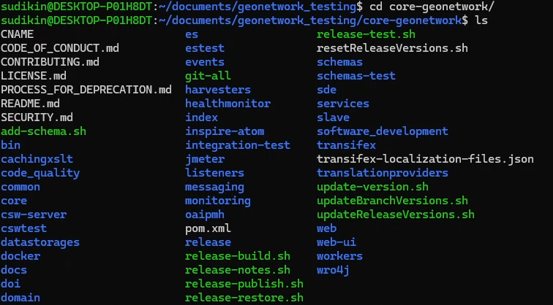

* 1. Clean install geo-network

To do the following we are using a maven command that removes all files generated by the previous build(clean command), compiles the code and installs the resulting artifacts into the local maven repository(install command) and setting the maven property skiptests to true such that maven will skip the execution of tests during installation(DskipTests).

sudikin@DESKTOP-P01H8DT: ~/documents/geonetwork_testing/core-geonetwork$ mvn clean install -DskipTests

1. Installing Elastic search
   1. Changing into the es directory

sudikin@DESKTOP-P01H8DT: ~/documents/geonetwork_testing$ rm -rf core-geonetwork/

sudikin@DESKTOP-P01H8DT: ~/documents/geonetwork_testing$ cd core-geonetwork/es

* 1. Installing the es

We have specified a maven build profile (-P command) to activate the es-download profile.Then we are installing the specific plugins, dependencies and configurations in es-downloads.

sudikin@DESKTOP-P01H8DT: ~/documents/geonetwork_testing/core-geonetwork/es$ mvn install -Pes-download

* 1. Executing the es-download

We are calling the exec plugin of maven to execute a program(exec:exec command).Then we are defining a system property es-start by using (-D command) of the -Des-start.

sudikin@DESKTOP-P01H8DT: ~/documents/geonetwork_testing/core-geonetwork/es$ mvn exec:exec -Des-start

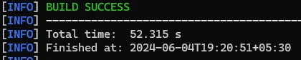

1. Creating geo-network web application

First we are changing into the web directory. We will start a jetty server with a web application. Hence we will use the jetty maven plugin to integrate the jetty web server into maven.

sudikin@DESKTOP-P01H8DT: ~/documents/geonetwork_testing/core-geonetwork$ cd web

sudikin@DESKTOP-P01H8DT: ~/documents/geonetwork_testing/core-geonetwork/web$ mvn jetty:run

1. Problem in finding the search service

After all being done the search service could not be found. This happens because Elasticsearch expects “https” access by default, but the server is not yet configured for this.

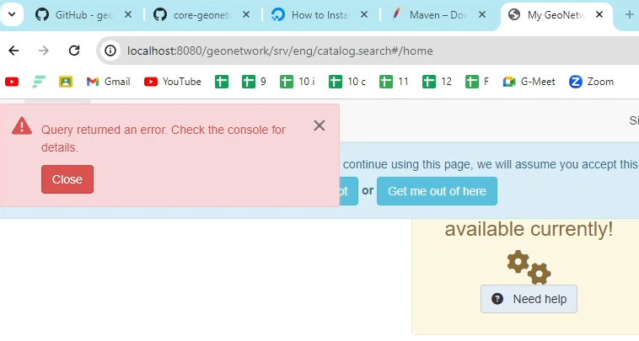To fix this, open the ‘elasticsearch.yml’ file in the es directory in any code editor (we used VS Code).

* 1. Opening vs code editor

sudikin@DESKTOP-P01H8DT:~/documents/geonetwork_testing/core-geonetwork/es$ code .

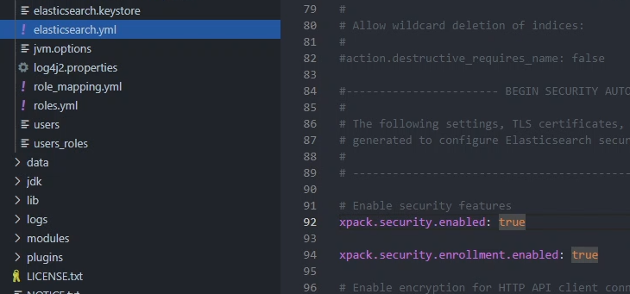

* 1. Changing line 92 to false

Change the xpack.security.enabled from true to false.This changes the elastic search default mode of https to http.

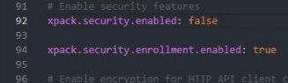

* 1. Repetition of previous steps

Repeat the steps 5(c) and 6 to execute elastic search and run the web.

1. Successfully running server

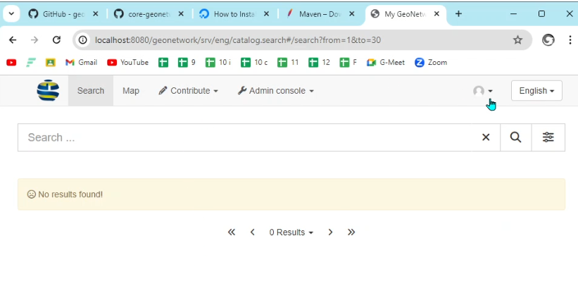

The web application with a running elastic search but without any data.

**To start my geo-network catalogue:**

1. Open terminal to run jetty
   1. Open terminal

Press the win key to open the terminal and write terminal to get into the powershell.Type ubuntu to go to the wsl mode.Type clear to clean the recent screen.

* 1. Open and run from the working directory of web

Change the working directory to web to see the availability of the documents required by us.

sudikin@DESKTOP-P01H8DT:~$ cd documents/geonetwork_testing/core-geonetwork/web

Running the jetty server with a web application.

sudikin@DESKTOP-P01H8DT:~/documents/geonetwork_testing/core-geonetwork/web$ mvn jetty:run

* 1. Open and run from the working directory of es

Open the working directory of es then start the execution of the elastic search.

sudikin@DESKTOP-P01H8DT:~$ cd documents/geonetwork_testing/core-geonetwork/es

sudikin@DESKTOP-P01H8DT:~/documents/geonetwork_testing/core-geonetwork/es$ mvn exec:exec -Des-start

* 1. Open a web browser and load geo network

Open any web browser and go to the following address in the address bar.It will open the geonetwork.

http://localhost:8080/geonetwork

**Why we built from source and chose not to use the docker container**

Docker containers are meant for production, and as such, it is not really modifiable. As we learnt more about how it works, we felt that it would be a better idea to build Geonetwork from source and not use it as a docker container. There was also the fact that building from source method was easier to startup and shut down, due to lack of compute power, docker container could not be stopped properly, and some processes did not stop at all calling for a forceful stop, which is not always recommended.

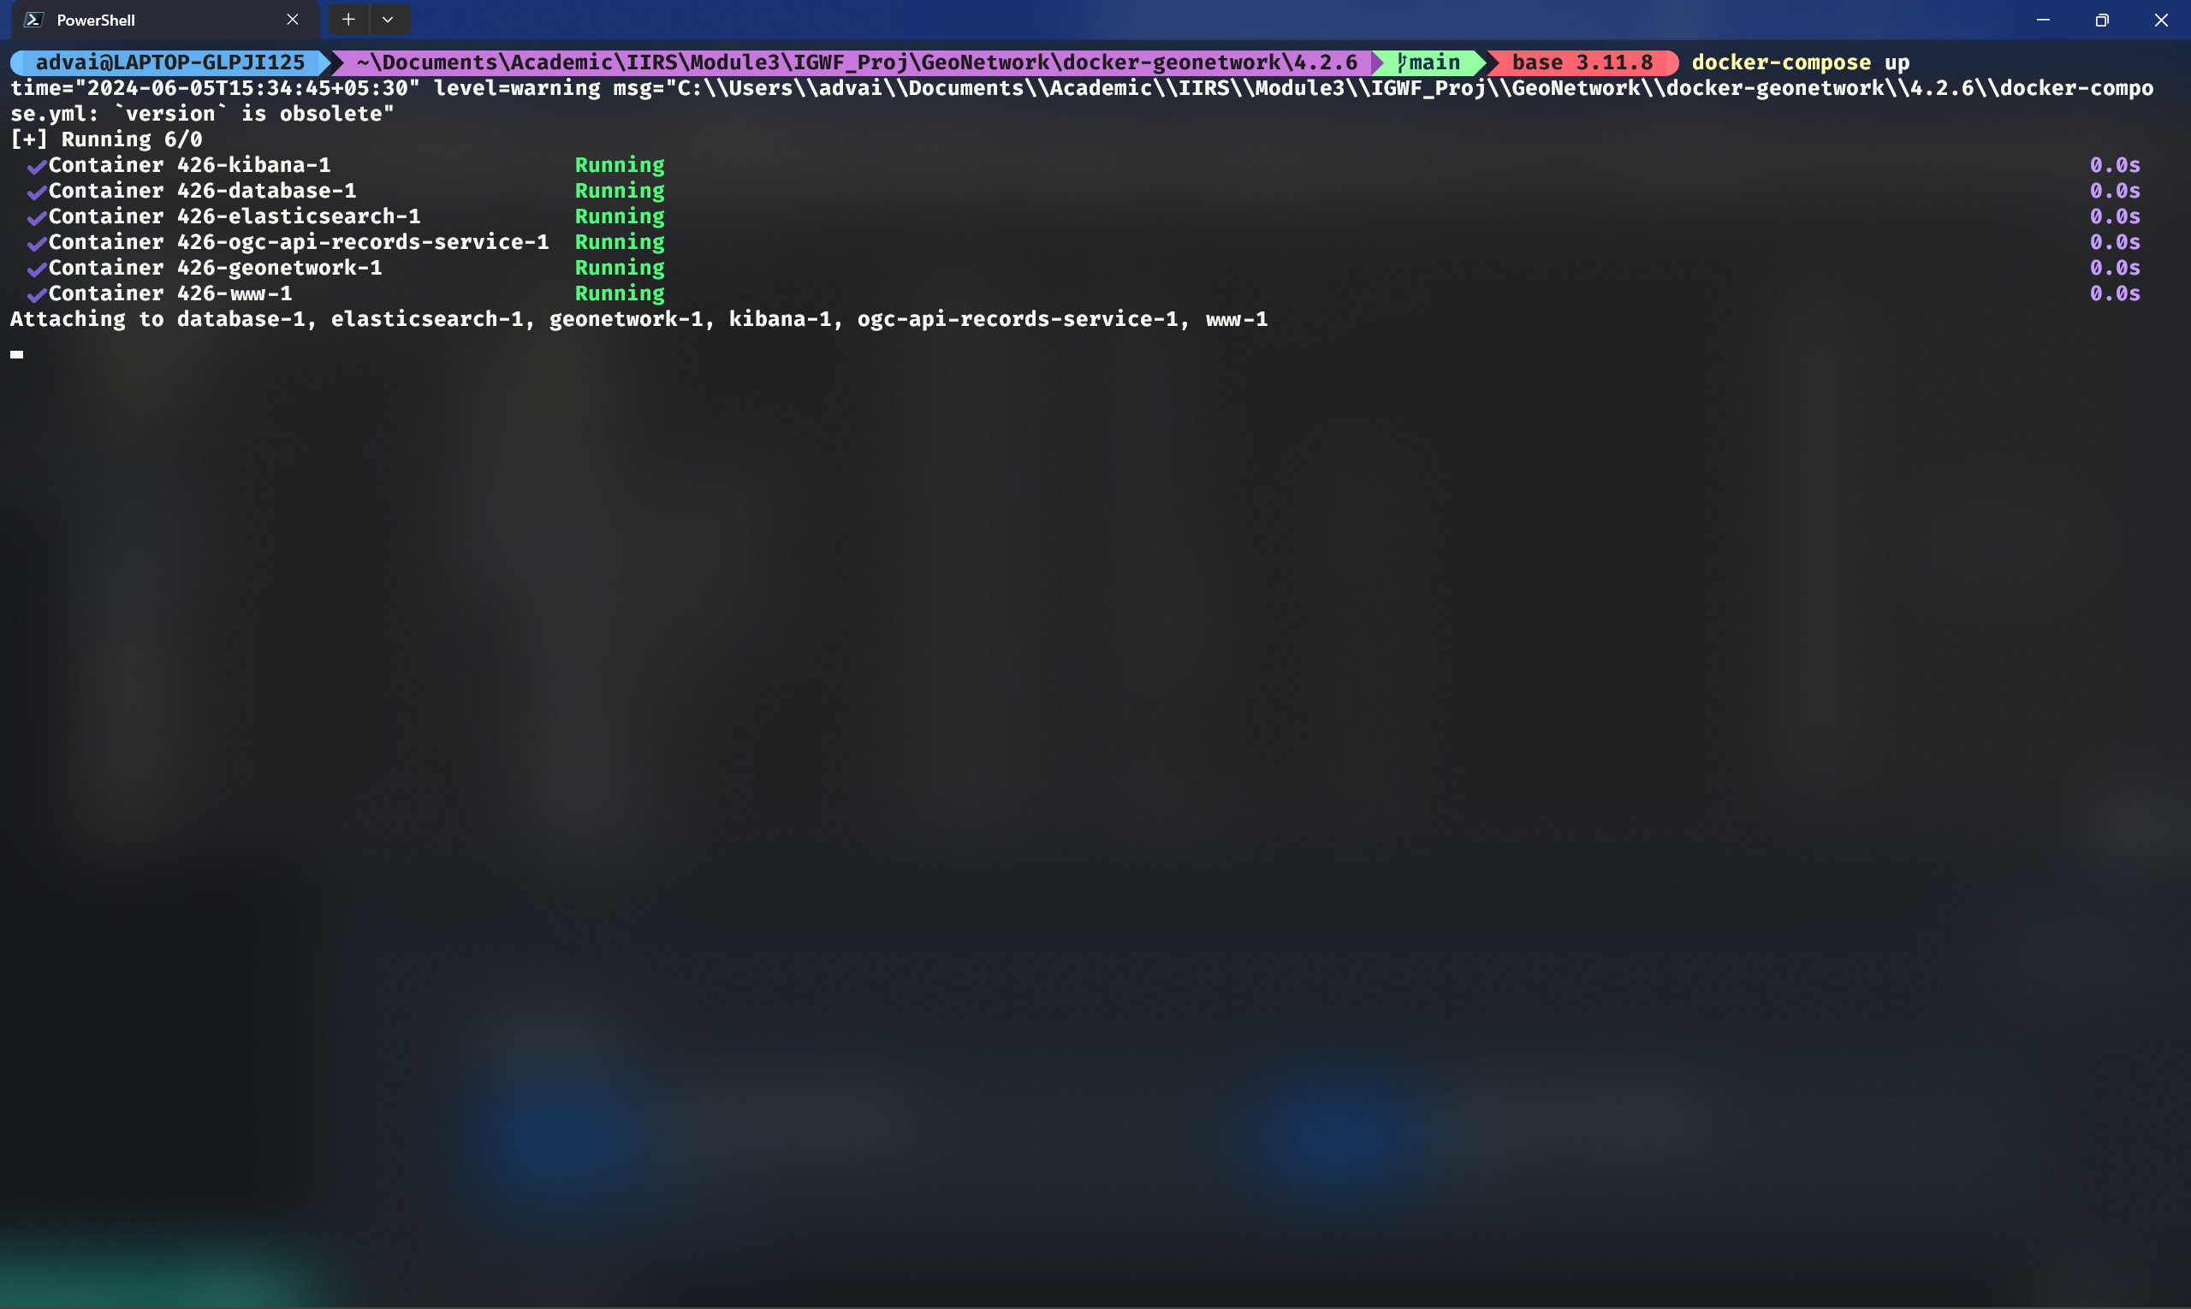

A screenshot showing the docker containers up and running for Geonetwork

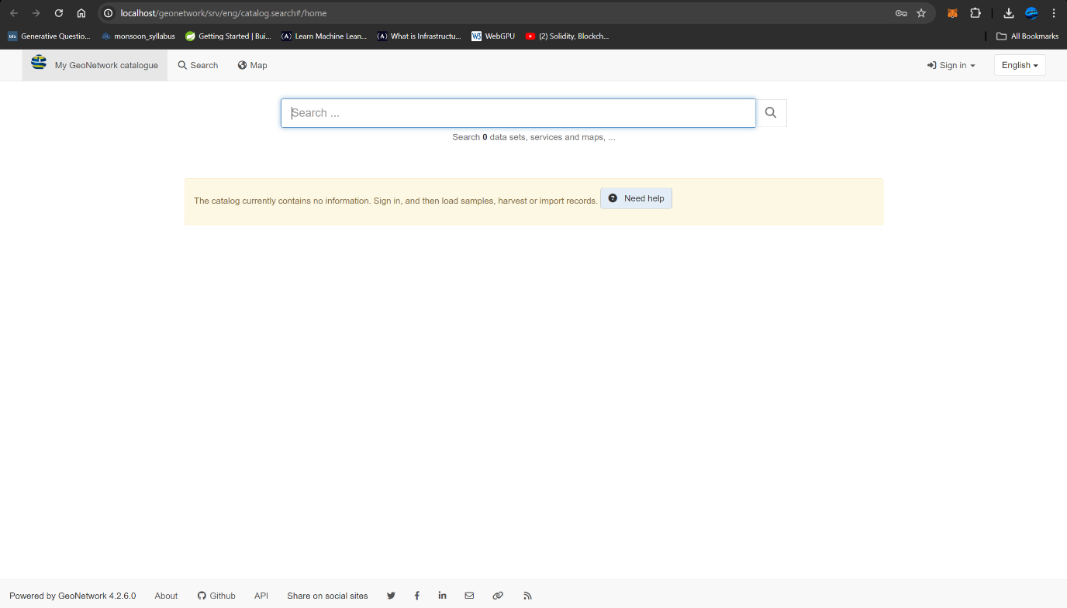

A screenshot of the Geonetwork instance running on docker

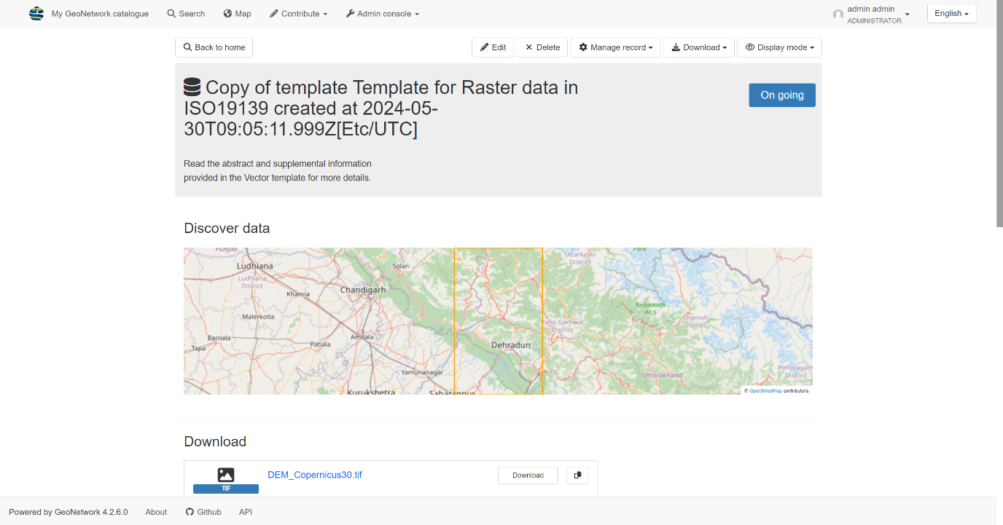

A screenshot of the same Geonetwork instance but with some data